Unidad 3 - Actividad 3

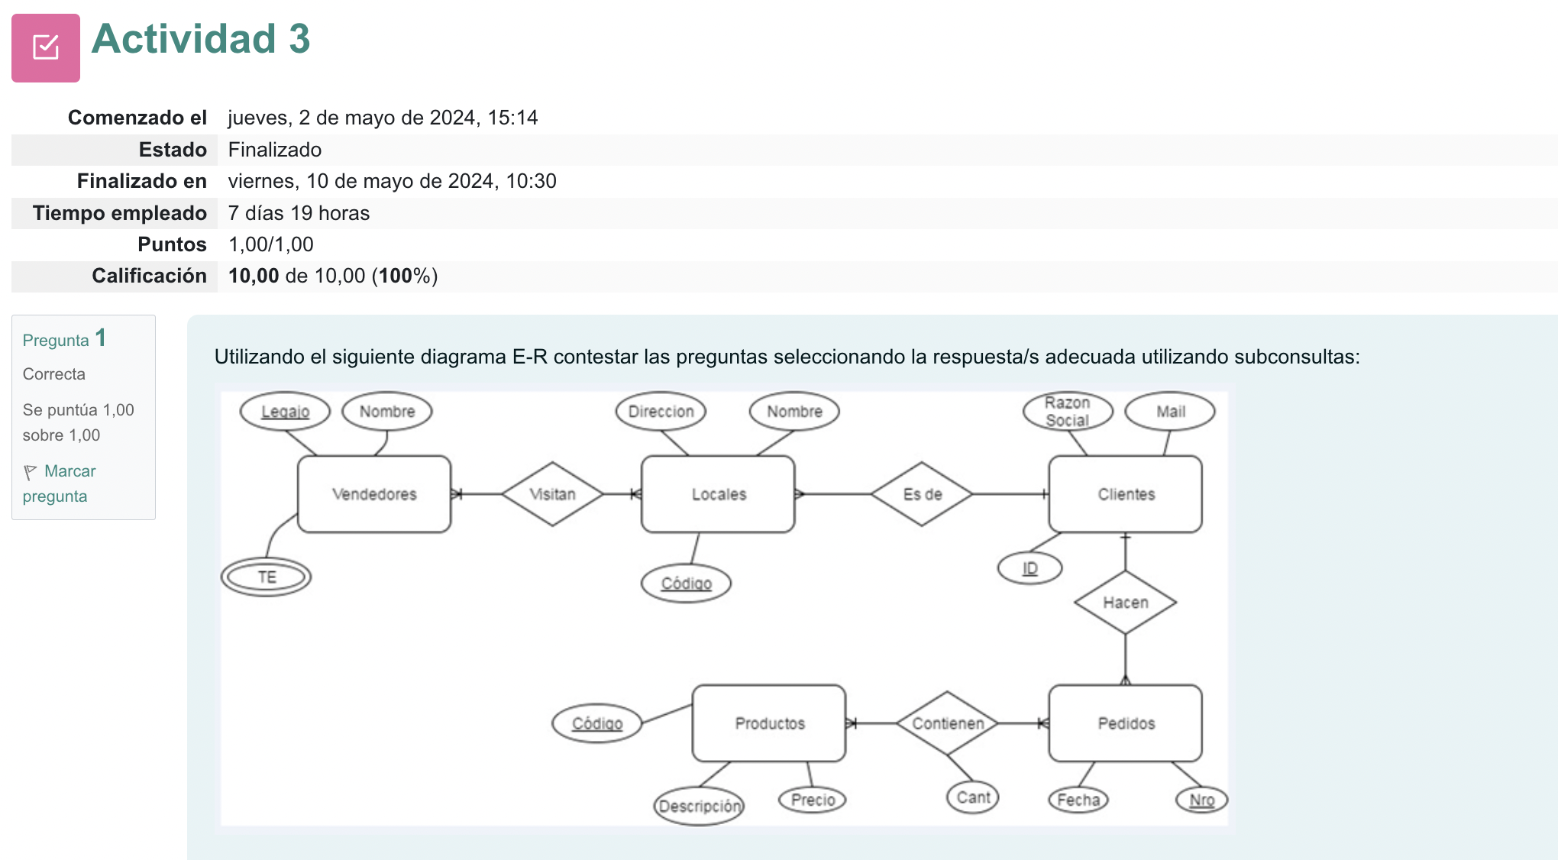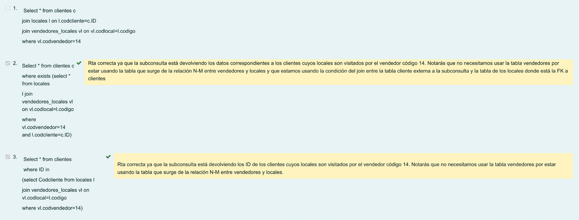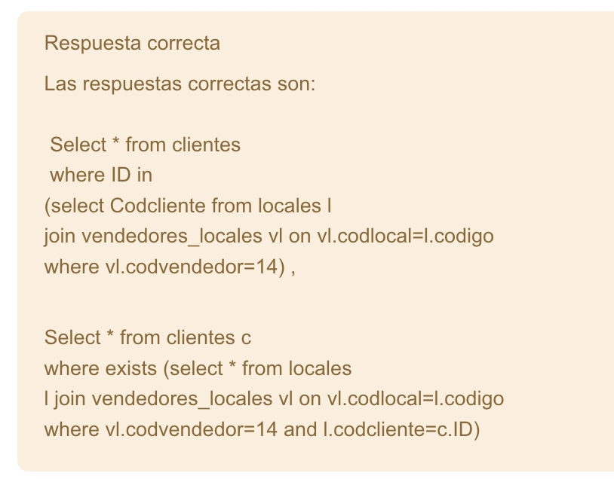

**Db**

Disenar db, not usual data

Porque, adjuntar info sobre eso, db sobre nubes de mosquitos, encontrarle la utilidad

Explicar todo el trabajo

**MySQL Server:**

Install mysql server:

**brew install mysql**

MySQL is configured to only allow connections from localhost by default

To connect run:

**mysql -u root**

To start mysql now and restart at login:

**brew services start mysql**

Or, if you don't want/need a background service you can just run:

**/opt/homebrew/opt/mysql/bin/mysqld_safe --datadir\=/opt/homebrew/var/mysql**

Chatgpt

To install MySQL Server on macOS, you can use Homebrew, a popular package manager for macOS. Here's a step-by-step guide:

Install Homebrew: If you haven't installed Homebrew yet, you can do so by opening Terminal and executing the following command:

**/bin/bash -c "$(curl -fsSL https://raw.githubusercontent.com/Homebrew/install/HEAD/install.sh)"**

Install MySQL Server: Once Homebrew is installed, you can use it to install MySQL Server. Run the following command in Terminal:

**brew install mysql**

Start MySQL Server: After the installation is complete, you can start the MySQL server by running the following command:

**brew services start mysql**

Secure MySQL Installation: It's recommended to secure your MySQL installation by running the following command and following the instructions:

**mysql_secure_installation**

This command will prompt you to set up a root password, remove anonymous users, disallow remote root login, and remove the test database. Follow the prompts to complete the process.

Verify Installation: You can verify that MySQL Server is running by executing the following command:

**brew services list**

This command should show mysql with started status.

Access MySQL: To access the MySQL command-line interface, you can use the following command:

**mysql -u root -p**

You will be prompted to enter the root password you set during the secure installation process.

That's it! You've now installed MySQL Server on your macOS system using Homebrew. You can start creating databases, tables, and managing your MySQL server as needed.